

EXPORT PROGRAM – Jenkins Day 1

October 16, 2017

ALBERTO ARAM RASCÓN GARCÍA

SYSTEMS ENGINEER

EPAM SYSTEM MEXICO.

[www.epam.com](http://www.epam.com/)

CONTENTS

1. Jenkins installation 3

1.1. Prerequisites 3

1.2. Installing jenkins 3

1.3. Starting jenkins 3

1.4. Log into Jenkins 4

2. Manually launching a Jenkins job 4

2.1. Create key pair 4

2.2. Create security group 5

2.3. Launch instance 5

2.4. lOG INTO INSTANCE 6

2.5. Install web server 6

2.6. Create AMI image 6

2.7. lAUNCH INSTANCE FROM ami 6

# Jenkins installation

## Prerequisites

To be able to run Jenkins we’ll need at least Java 1.8 available in our default java package

# yum install java



## Installing jenkins

We can add one or many users to our new group

# wget --O /etc/yum.repos.d/jenkins.repo <http://pkg.jenkins-ci.org/redhat/jenkins.repo>

# rpm --import <https://jenkins-ci.org/redhat/jenkins-ci.org.key>

# yum install Jenkins -y

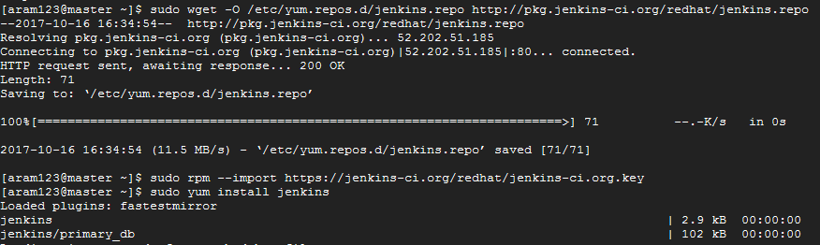

## Starting jenkins

By default Jenkins will start automatically, in case this is not true, we can manually start it with systemctl:

# systemctl start jenkins



## Log into Jenkins

Jenkins should be available at our public IP address on the port 8080, in this case we can find it at:

http://35.192.69.236:8080/

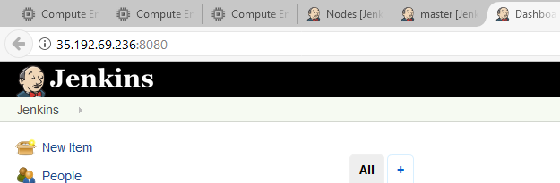

# Manually launching a Jenkins job

## Creating a job

A job can be created selectioning the new item option on the dashboard:

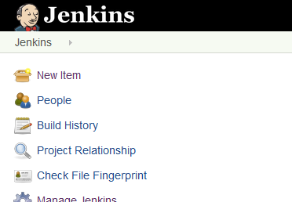

We just have to enter a name, select Freestyle project and hit the ok button.

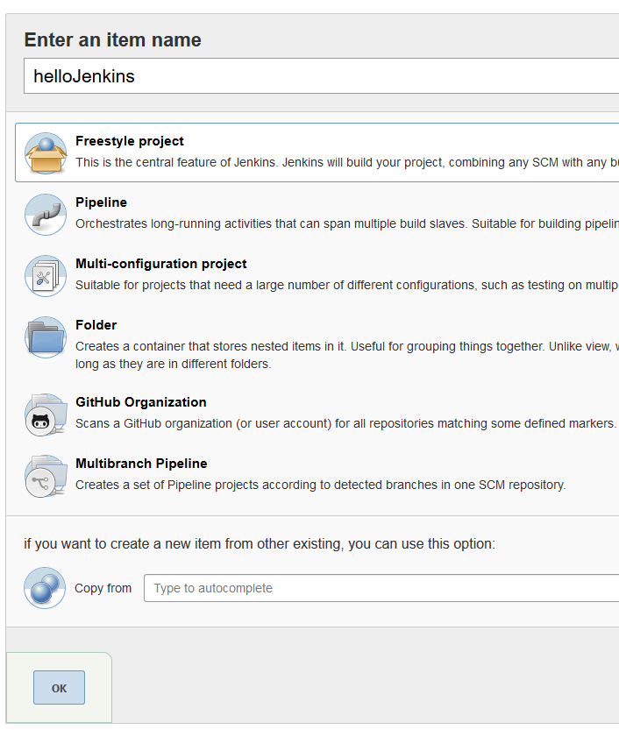

Later, we’ll give our project a name and possibly a description.

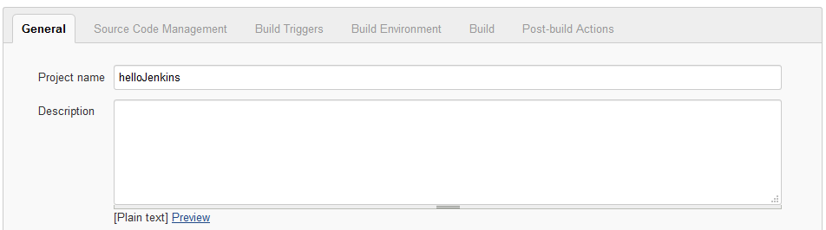

In the build section, we can choose to add a build step and execute a command.

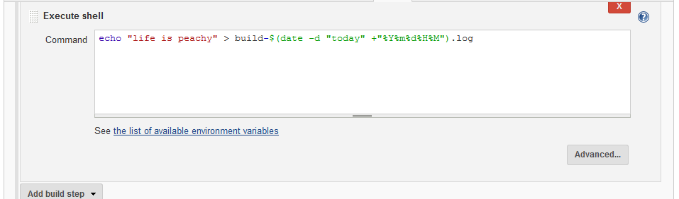

At this point our Jenkins job is complete, we can save it for testing.

We can test our new job with the build now option:

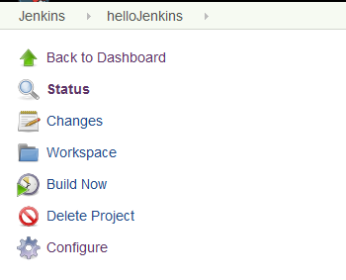

Once that we choose this option, we can get the output of our script in the console output option.

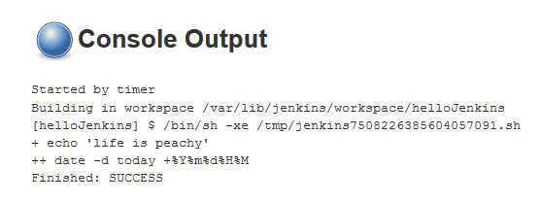

# Automatically launching a Jenkins job

## Setting up build triggers

One of the simplest way to automatically launcing a job it’s using a cron job every “X” time, to use this option we just have to check the Build periodically option on the build triggers section and set up the schedule, in the next example the job will be executed every 5 minutes:

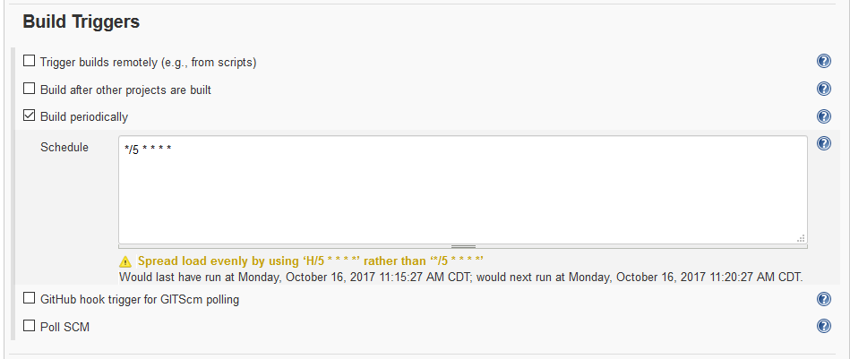

At this point all is left to do it’s waiting some time to let the jobs run a few times:

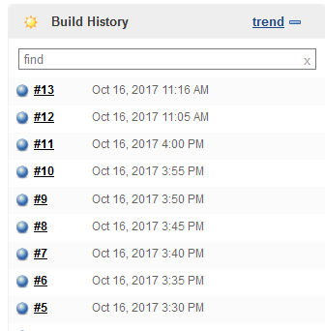

Everything was executed correctly:

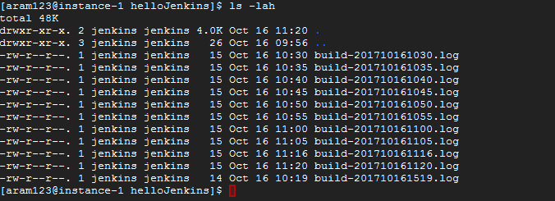

# Installing jenkins agent on a different machine

## lOG INTO INSTANCE

$ ssh -i "poseidonKey.pem" ec2-user@ec2-34-230-90-16.compute-1.amazonaws.com

## Install web server

We’ll use yum as always:

# yum install nginx

## Create AMI image

$ aws ec2 create-image --instance-id i-0478f1d97f66b6041 --name "Poseidon's AMI Image" --description "It's pretty much vanilla"

## lAUNCH INSTANCE FROM ami

$ aws ec2 run-instances --image-id ami-e19c4a9b --count 1 --instance-type t2.micro --key-name poseidonKey --security-groups godsGroup --region us-east-1